Active Hospitals Role Description
Title: Active Hospitals Volunteer

Division: Corporate

Grade: Volunteer (non-salaried)

Expenses: Entitled to claim travel expenses in accordance with the NUH Trust expenses policy

Reports to:
Accountable to: Voluntary Services

About Nottingham University Hospitals

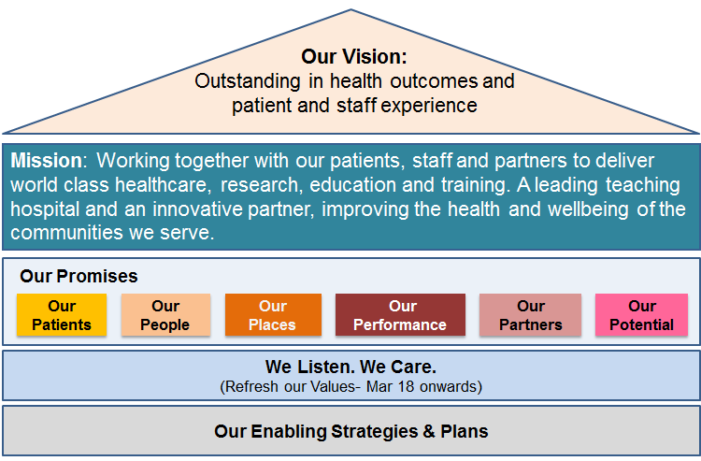
- Patients - We will ensure our patients receive consistently high quality, safe care with outstanding outcomes and experience
- People - We will build on our position as an employer of choice; with an engaged, developed and empowered team that puts patient care at the heart of everything it does
- Places - We will invest in our estate, equipment and digital infrastructure to support the delivery of high quality patient care
- Performance - We will consistently achieve our performance standards and make the best use of resources to contribute to an affordable healthcare system
- Partners - We will support the improvement of the health of the communities we serve through strong system leadership and innovative partnerships to deliver integrated models of care
- Potential - We will deliver world-class research and education and transform health through innovation

Our values are: Caring and helpful; Safe and Vigilant for our patients and colleagues; Being Clinically Excellent and driving innovation to meet the needs of our patients; Using our Resources wisely whilst; Providing Quality products, services and experiences for staff and patients
VALUES AND BEHAVIOURS:

NUH has a set of values and behaviours to improve the experience for our patients and our staff (We are here for you). This means that in undertaking this role the post holder is expected at all times to behave is a way that demonstrates commitment to the delivery of thoughtful patient care and continuous improvement as detailed in the table below.
Thoughtful Patient Care | Continuous Improvement
Caring and helpful  - Polite, respect individuals, thoughtful, welcoming  - Helpful, kind, supportive, don’t wait to be asked  - Listening, informing, communicating | Accountable and reliable  - Reliable and happy to be measured  - Appreciative of the contribution of others  - Effective and supportive team-working
Safe and vigilant  - Clean hands and hospital so patients are safe  - Professional, ensure patients feel safe  - Honest, will speak up if needed to stay safe | Best use of time & resources  - Simplify processes, to find more time to care  - Eliminate waste, investing for patients  - Making best use of every pound we spend
Clinically excellent  - Best outcomes through evidence-led clinical care  - Compassionate, gentle, see whole person  - Value patients’ time to minimise waiting | Innovation for patients  - Empowerment to act on patient feedback  - Improvement led by research and evidence  - Teaching the next generation

GENERAL ROLES

- Replenish Active Hospitals’ patient information by beds, and update the notice boards
- Speak to ward staff on individual bays about who is appropriate for a “Keeping Moving” bed or chair exercise session.
- Speak to ward staff about how to safely support the patient with bed and chair exercises.
- Ensure that patients have access to the “Keeping Moving” sheet.
- Ensure that patient environment is safe for bed or chair exercises, and remove any obstacles.
- Speak immediately to ward staff if a patient becomes unwell, is in pain, is at risk of falls during a session, or if anything untoward happens.
- Lead patient through warm up, bed or chair exercises, warm down.
- Give feedback to patients on their performance, to help them to do the exercises properly and safely.
- Recognise when a patient cannot follow the exercises independently and feed this back to ward staff.
- Feedback on the session to ward staff verbally at its’ end.
- Feedback any concerns as appropriate to the nurse in charge

In addition to the key job responsibilities detailed in this job description all volunteers at Nottingham University Hospitals NHS Trust are expected to comply with the general duties detailed below:

Role Requirements

Volunteers must keep their annual mandatory training up to date as per Trust policy

Volunteers must be aware and understand their confidentiality training and obligations when signing their confidentiality declaration.

Volunteers are not permitted to share or disclose information discovered or discussed whilst volunteering. This role does not require volunteers to store or copy confidential information on duty or whilst at home.

Volunteers will comply with all health and safety training, instructions and policies whilst performing their role

Volunteers will report all accidents and incidents immediately to their first point line managers or appropriate staff. If Voluntary Services have not been informed of an accident, volunteers must inform Voluntary Services as soon as it is safe to do so.

Volunteers must adhere to all Trust and Departmental policies and procedures at all times.

Volunteers must report all concerns/complaints and departmental issues to their first point line managers or appropriate staff immediately

In addition to the key job responsibilities detailed in this volunteer description, all volunteers at Nottingham University Hospitals NHS Trust are expected to comply with the general duties detailed below:
Infection Control
To ensure adherence to the Trust’s standards of cleanliness, hygiene and infection control when in clinical areas and Trust buildings. Volunteers must also be mindful of their obligations to Infection control in clinical emergency situations such as discovering contaminated areas/items and in pandemic situations.

Safeguarding children, young people and vulnerable adults
Nottingham University Hospitals is committed to safeguarding and promoting the welfare of children, young people and vulnerable adults. All staff and volunteers are therefore expected to behave in such a way that supports this commitment.
Information Governance
Volunteers have an individual responsibility for the upkeep of records pertaining to their role and for managing all NHS records effectively in line with the Health Record Keeping Policy and other Health Records and Corporate Records Management policies and procedures in order to meet the Trust’s legal, regulatory and accountability requirements.

Health and Safety
To take reasonable care to prevent injury to themselves or others who may be affected by their acts or omissions.

To co-operate fully in discharging the Trust policies and procedures with regard to health and safety matters, where applicable

To immediately report to the Trust any shortcomings in health and safety procedures and practice.

To report any accidents or dangerous incidents to their immediate manager and safety representative as early as possible and submit a completed accident/incident form.

To use protective clothing and equipment where provided, where applicable

Whilst the aim of the Trust is to promote a co-operative and constructive view of health and safety concerns in the organisation, all staff must be aware that a wilful or irresponsible disregard for safety matters may give rise to disciplinary proceedings.

General Policies Procedures and Practices
To comply with all Trust policies, procedures and practices under the guidance of the voluntary services and the departments within which volunteering, where applicable.

ROLE REVISION
This Role description should be regarded as a guide to the duties required and is not definitive or restrictive in any way. The duties of the post may be varied from time to time in response to changing circumstances.

HEALTH DECLARATION

Your role as a volunteer has been explained to you and a clear description of your duties is given above. To the best of your Knowledge are you in good health and capable of undertaking the duties of a volunteer safely? YES/NO

Do you have health issues that we need to know about? ______________________________________

It will be your responsibility to inform the Voluntary Services Office immediately if there is any change to your health in the future.

Signed: _____________________________ Date: ________________________

