**Nervecentre**

**Physical Activity Assessment**

**Quick Reference Guide**

Physical inactivity accounts for 1 in 6 UK deaths, which is equivalent to smoking.

"If physical activity were a drug, we would refer to it as a miracle cure, due to the great many illnesses it can prevent and help treat"

Adults should aim for 150 minutes moderate exercise a week, and under 18s 60 minutes a day. We should all break up sedentary behaviour, and build strength and balance. (UK Chief Medical Officers' Physical Activity Guidelines 2019)

This can lead to:

• Reduction in hip fractures by up to 68%

• Reduction in diabetes by up to 40%

• Reduction in cardiovascular disease by up to 35%

• Reduction in all-cause mortality by up to 30%

(Public Health England, Applying All Our Health, 2019)

**The** **Nervecentre Physical Activity Assessment** is a way to understand how active our patients usually are. This will help us to know what advice to give them. It is not a current mobility/falls risk assessment.

It can be filled in retrospectively. It can be saved and completed at a later point.

To begin the Physical Activity Assessment make sure that you have selected the correct patient name.

Select ‘Assessments’, select the ‘+’ button in the top right corner of the screen, then select the Physical Activity Assessment.

On your first assessment, click the **HELP** box before starting to talk to the patient, as it contains advice on how to begin the assessment. On starting the assessment, you will be asked: Is the patient willing and able to answer questions about their physical activity? If ‘yes’, click the Yes button and then Next and ask the patient the first two questions. Enter the days/minutes in the boxes.

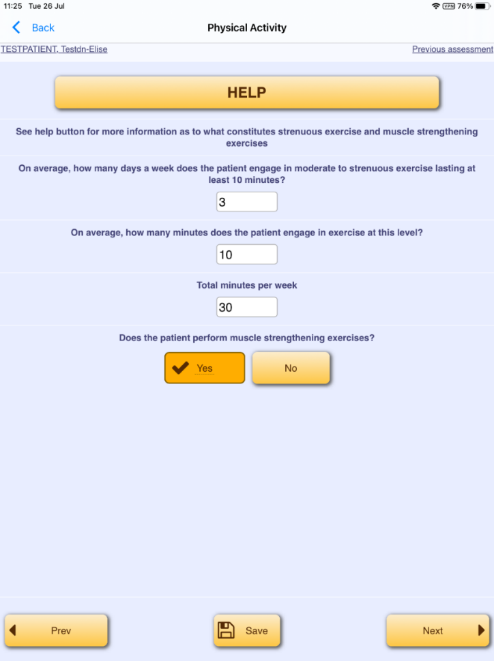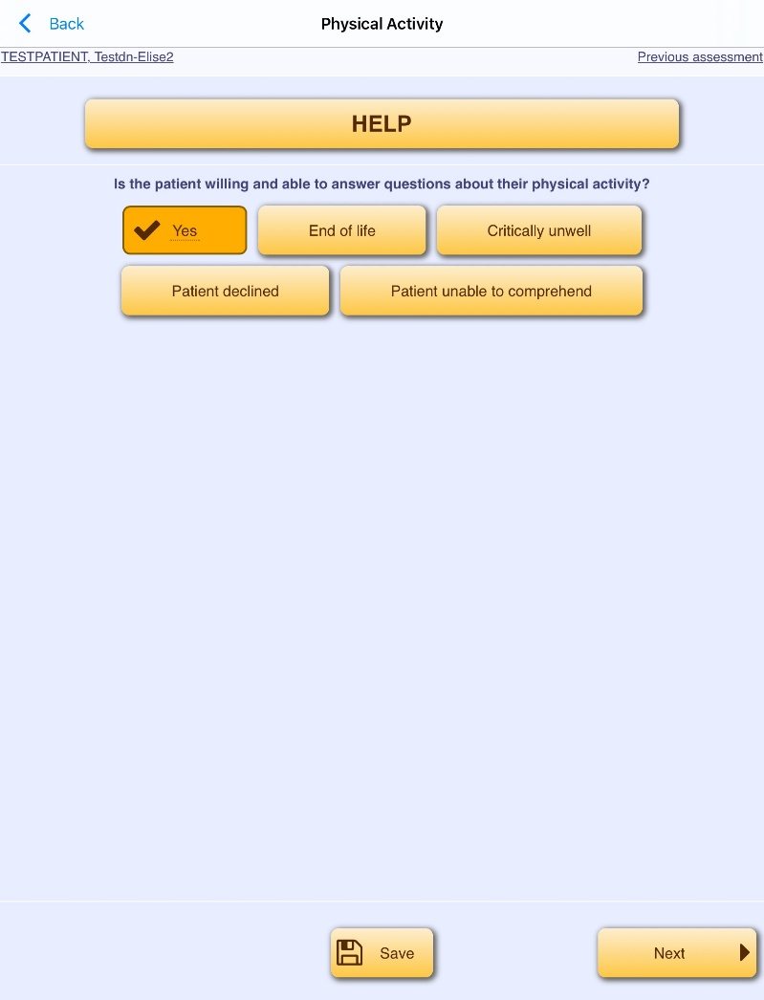

The **HELP** button on the second page contains advice about physical activity which you can share with the patient, including what “moderate” and “strenuous”, and “strength building” exercise mean.

Exercise can include walking to the toilet, dressing, cooking, cleaning, moving in bed, climbing the stairs. Include anything that the patient reports makes them feel breathless and warm.

The total minutes will be calculated based on your answers.

Ask the third “muscle strengthening” question, and click Yes or No. For example, in the case of shopping, this would be a muscle strengthening exercise, and you would click Yes.

Click Next at the bottom of the page.

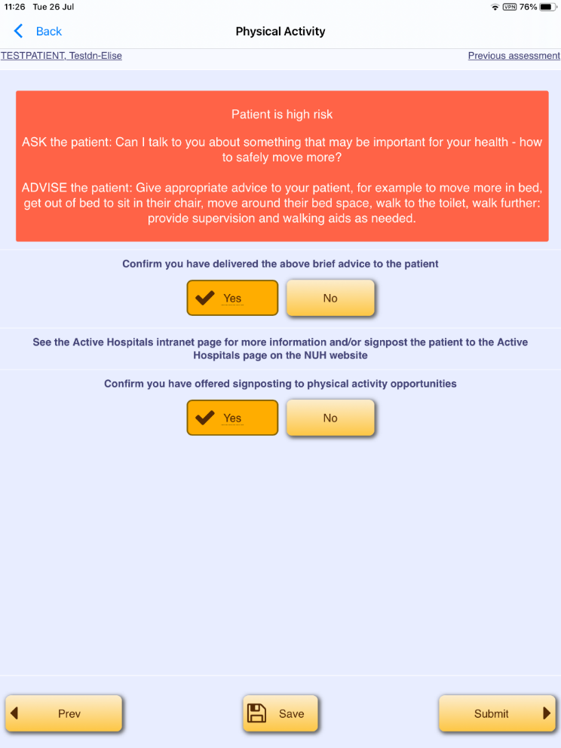

You will be taken to a screen with a level of risk stated. This refers to the risk to the person’s health through their previous levels of physical activity, not their current mobility or risk of falls.

If the patient is low risk, or green, advise that their previous physical activity levels have been beneficial to their health.

In all cases, discuss this further.

Ask the patient: “Can I talk to you about something that may be important for your health: Moving More?” Give advice; examples are shown on the screen. Try to avoid being directive, and instead say things like “How would you feel about practicing getting out of bed”, or “Do you think being more active on the ward could help you?” Provide advice on how to mobilise safely if their mobility has been affected by accident or illness. Once advice is given, click Yes.

If you are unable to deliver this advice, click No. You will then need to complete a mandatory free text box to explain why.

If there are any physical activity opportunities (e.g. exercise sheets or sessions), or patient information (e.g. leaflets, visible information board) on the ward, tell the patient about them, and click “Yes” in the bottom (signposting to physical activity opportunities) box. If there are no physical activity opportunities on the ward, you can show the patient the Active Hospitals page on the NUH internet pages. [Active Hospitals | NUH](https://www.nuh.nhs.uk/active-hospitals)

Click Yes to confirm that you have offered signposting.

If there are no physical activity opportunities on the ward, and you cannot show the patient any ward information, or the website information, click No. Again, you will need to complete a mandatory free text box to explain why. Click Submit at the bottom of the page. The assessment is now complete.

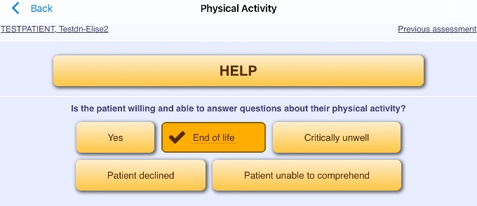

If “End of life” is the most appropriate response, click on this and then Next. The assessment has now been completed and no further actions are required.

If the patient is critically unwell, click “Critically unwell” then Next. You will be sent to a free text box to enter the nature of their illness. Enter the reason then click Submit. You will be prompted to repeat the assessment every other day until either it is completed, or the patient is discharged home. It will become due after 23 hours and overdue after 24 hours.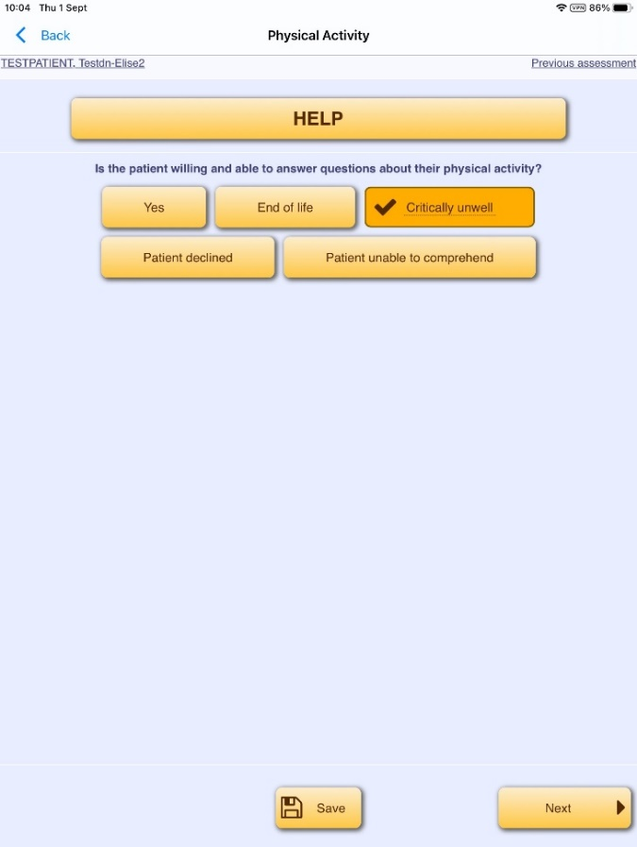

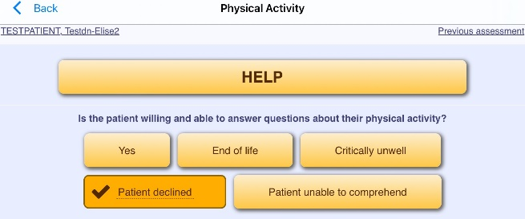 If the patient declines the assessment, click “Patient declined” then Next. You will be sent to a free text box to enter the reason why. Enter the reason then click Submit. The assessment will be due 23 hours later, and overdue 24 hours later. If the patient declines once again, there will be no further actions.

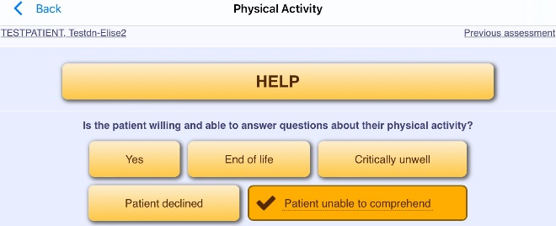If the patient is initially unable to comprehend the questions, give them time and support; use simple language, repetition, and written information or pictures if helpful. If the patient continues to be unable to comprehend the assessment, click the “Patient unable to comprehend” button, and Next. On the next screen, complete the free text box to explain why, then click Submit. You will be prompted to repeat the assessment every other day until it is either completed or the patient is discharged home. The assessment will become due after 46 hours, and overdue after 48 hours.

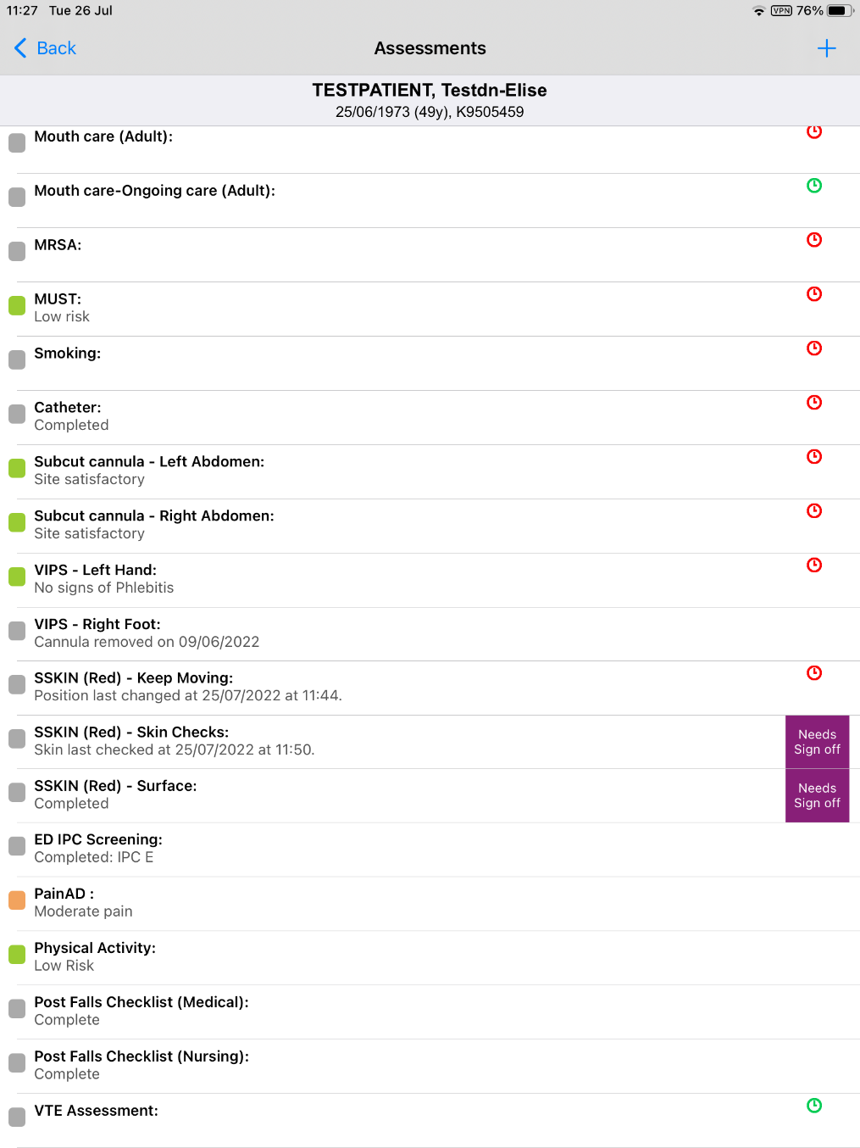



If the assessment has been completed, the “Physical Activity” assessment will colour code to their level of risk. This colour relates to the risk to their health associated with their level of physical activity. It is not a current mobility or falls risk assessment.

Alternatively, you could have a message related to the option you chose, such as EOL.

If the assessment needs to be repeated (for example if the patient is critically unwell or unable to comprehend) you will see a green clock if the assessment is due, or a red clock if the assessment is overdue.