

**Active Wards Toolkit**

**Nottingham University Hospitals Trust**



*Active Hospitals is developed in partnership with the Office for Health Improvement & Disparities and Sport England*

cid:image001.png@01D92CBC.0814E080

**Overview.**

Physical Activity is good for all of us and any activity is better than none. Active Hospitals aims to change the culture of Acute Hospitals from places of rest and recuperation, to places of movement and recovery.  By opening up a dialogue between patient and health care professionals about physical activity (moving more and sitting less), we can improve health outcomes.

Physical Inactivity costs the NHS £1 billion a year and is responsible for 1 in 6 UK deaths (which is equivalent to smoking). One person dies of physical inactivity every 15 minutes. It is the fourth greatest cause of ill health in the UK.

People with long term health conditions are two times more likely to be inactive than the general population.

Hospitals, and illness, are associated with rest. However, moving more in hospital leads to better health outcomes. 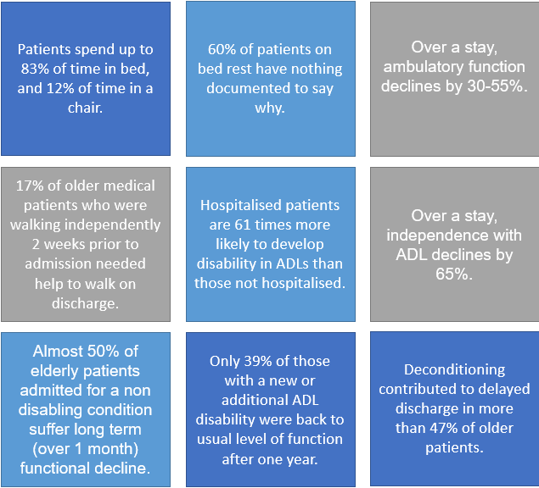

Hospital deconditioning has an impact on our patient's health, delaying discharge, and leading to higher levels of disability post-discharge. Physical activity within our hospitals can lead to shorter patients’ stays, and fewer complications.

The moving medicine website has a wealth of information and resources, and we recommend you familiarise yourself with their advice on having 1 minute, 5 minute, and more minutes conversations with patients.

[Homepage - Moving Medicine](https://movingmedicine.ac.uk/)

**Training**

Training your staff is an essential first step in becoming an “Active Ward”

**ESR modules**

|  |  |  |
| --- | --- | --- |
| No Course Image | | [000 All Our Health: Physical Activity](https://my.esr.nhs.uk/OA_HTML/OA.jsp?page=/oracle/apps/ota/learner/webui/LearnerHomePG&OAHP=OTA_LEARNER_APPLICATION_MENU&OASF=OTA_LEARNER_HOME_SS&OAFunc=OTA_LEARNER_HOME_SS&OAPB=OTA_PRODUCT_BRANDING&_ti=386375709&language_code=US&pAMETranType=SSHRMS&pAMEAppId=800&pProcessName=XX_V5_NHS_ADM_LNR_TRG_APP_PRC&pCalledFrom=OTA_LEARNER_HOME_SS&pItemType=HRSSA&pFromMenu=Y&pApprovalMode=YD&pCertProcessName=XX_V5_OTA_CERT_APPROVL_JSP_PRC&pCertApprovalMode=Y&pNtfFyiDetails=Y&&oapc=2&oas=sBUT3tDYu_RJLJ29pTsbQg..) |
| No Course Image | | [000 Physical Activity and Health: Cancer Conditions: Being Active](https://my.esr.nhs.uk/OA_HTML/OA.jsp?page=/oracle/apps/ota/learner/webui/LearnerHomePG&OAHP=OTA_LEARNER_APPLICATION_MENU&OASF=OTA_LEARNER_HOME_SS&OAFunc=OTA_LEARNER_HOME_SS&OAPB=OTA_PRODUCT_BRANDING&_ti=386375709&language_code=US&pAMETranType=SSHRMS&pAMEAppId=800&pProcessName=XX_V5_NHS_ADM_LNR_TRG_APP_PRC&pCalledFrom=OTA_LEARNER_HOME_SS&pItemType=HRSSA&pFromMenu=Y&pApprovalMode=YD&pCertProcessName=XX_V5_OTA_CERT_APPROVL_JSP_PRC&pCertApprovalMode=Y&pNtfFyiDetails=Y&&oapc=2&oas=sBUT3tDYu_RJLJ29pTsbQg..) |
| No Course Image | | [000 Physical Activity and Health: Cardiovascular Conditions: Being Active](https://my.esr.nhs.uk/OA_HTML/OA.jsp?page=/oracle/apps/ota/learner/webui/LearnerHomePG&OAHP=OTA_LEARNER_APPLICATION_MENU&OASF=OTA_LEARNER_HOME_SS&OAFunc=OTA_LEARNER_HOME_SS&OAPB=OTA_PRODUCT_BRANDING&_ti=386375709&language_code=US&pAMETranType=SSHRMS&pAMEAppId=800&pProcessName=XX_V5_NHS_ADM_LNR_TRG_APP_PRC&pCalledFrom=OTA_LEARNER_HOME_SS&pItemType=HRSSA&pFromMenu=Y&pApprovalMode=YD&pCertProcessName=XX_V5_OTA_CERT_APPROVL_JSP_PRC&pCertApprovalMode=Y&pNtfFyiDetails=Y&&oapc=2&oas=sBUT3tDYu_RJLJ29pTsbQg..) |
| No Course Image | | [000 Physical Activity and Health: Children and Young People: Being Active](https://my.esr.nhs.uk/OA_HTML/OA.jsp?page=/oracle/apps/ota/learner/webui/LearnerHomePG&OAHP=OTA_LEARNER_APPLICATION_MENU&OASF=OTA_LEARNER_HOME_SS&OAFunc=OTA_LEARNER_HOME_SS&OAPB=OTA_PRODUCT_BRANDING&_ti=386375709&language_code=US&pAMETranType=SSHRMS&pAMEAppId=800&pProcessName=XX_V5_NHS_ADM_LNR_TRG_APP_PRC&pCalledFrom=OTA_LEARNER_HOME_SS&pItemType=HRSSA&pFromMenu=Y&pApprovalMode=YD&pCertProcessName=XX_V5_OTA_CERT_APPROVL_JSP_PRC&pCertApprovalMode=Y&pNtfFyiDetails=Y&&oapc=2&oas=sBUT3tDYu_RJLJ29pTsbQg..) |
| No Course Image | | [000 Physical Activity and Health: Introduction to Physical Activity](https://my.esr.nhs.uk/OA_HTML/OA.jsp?page=/oracle/apps/ota/learner/webui/LearnerHomePG&OAHP=OTA_LEARNER_APPLICATION_MENU&OASF=OTA_LEARNER_HOME_SS&OAFunc=OTA_LEARNER_HOME_SS&OAPB=OTA_PRODUCT_BRANDING&_ti=386375709&language_code=US&pAMETranType=SSHRMS&pAMEAppId=800&pProcessName=XX_V5_NHS_ADM_LNR_TRG_APP_PRC&pCalledFrom=OTA_LEARNER_HOME_SS&pItemType=HRSSA&pFromMenu=Y&pApprovalMode=YD&pCertProcessName=XX_V5_OTA_CERT_APPROVL_JSP_PRC&pCertApprovalMode=Y&pNtfFyiDetails=Y&&oapc=2&oas=sBUT3tDYu_RJLJ29pTsbQg..) |
| No Course Image | | [000 Physical Activity and Health: Mental Health: Being Active](https://my.esr.nhs.uk/OA_HTML/OA.jsp?page=/oracle/apps/ota/learner/webui/LearnerHomePG&OAHP=OTA_LEARNER_APPLICATION_MENU&OASF=OTA_LEARNER_HOME_SS&OAFunc=OTA_LEARNER_HOME_SS&OAPB=OTA_PRODUCT_BRANDING&_ti=386375709&language_code=US&pAMETranType=SSHRMS&pAMEAppId=800&pProcessName=XX_V5_NHS_ADM_LNR_TRG_APP_PRC&pCalledFrom=OTA_LEARNER_HOME_SS&pItemType=HRSSA&pFromMenu=Y&pApprovalMode=YD&pCertProcessName=XX_V5_OTA_CERT_APPROVL_JSP_PRC&pCertApprovalMode=Y&pNtfFyiDetails=Y&&oapc=2&oas=sBUT3tDYu_RJLJ29pTsbQg..) |
| No Course Image | | [000 Physical Activity and Health: Musculoskeletal Health: Being Active](https://my.esr.nhs.uk/OA_HTML/OA.jsp?page=/oracle/apps/ota/learner/webui/LearnerHomePG&OAHP=OTA_LEARNER_APPLICATION_MENU&OASF=OTA_LEARNER_HOME_SS&OAFunc=OTA_LEARNER_HOME_SS&OAPB=OTA_PRODUCT_BRANDING&_ti=386375709&language_code=US&pAMETranType=SSHRMS&pAMEAppId=800&pProcessName=XX_V5_NHS_ADM_LNR_TRG_APP_PRC&pCalledFrom=OTA_LEARNER_HOME_SS&pItemType=HRSSA&pFromMenu=Y&pApprovalMode=YD&pCertProcessName=XX_V5_OTA_CERT_APPROVL_JSP_PRC&pCertApprovalMode=Y&pNtfFyiDetails=Y&&oapc=2&oas=sBUT3tDYu_RJLJ29pTsbQg..) |
| No Course Image | | [000 Physical Activity and Health: Older Adults: Being Active](https://my.esr.nhs.uk/OA_HTML/OA.jsp?page=/oracle/apps/ota/learner/webui/LearnerHomePG&OAHP=OTA_LEARNER_APPLICATION_MENU&OASF=OTA_LEARNER_HOME_SS&OAFunc=OTA_LEARNER_HOME_SS&OAPB=OTA_PRODUCT_BRANDING&_ti=386375709&language_code=US&pAMETranType=SSHRMS&pAMEAppId=800&pProcessName=XX_V5_NHS_ADM_LNR_TRG_APP_PRC&pCalledFrom=OTA_LEARNER_HOME_SS&pItemType=HRSSA&pFromMenu=Y&pApprovalMode=YD&pCertProcessName=XX_V5_OTA_CERT_APPROVL_JSP_PRC&pCertApprovalMode=Y&pNtfFyiDetails=Y&&oapc=2&oas=sBUT3tDYu_RJLJ29pTsbQg..) |
| No Course Image | | [000 Physical Activity and Health: Pregnancy and Postnatal Period: Being Active](https://my.esr.nhs.uk/OA_HTML/OA.jsp?page=/oracle/apps/ota/learner/webui/LearnerHomePG&OAHP=OTA_LEARNER_APPLICATION_MENU&OASF=OTA_LEARNER_HOME_SS&OAFunc=OTA_LEARNER_HOME_SS&OAPB=OTA_PRODUCT_BRANDING&_ti=386375709&language_code=US&pAMETranType=SSHRMS&pAMEAppId=800&pProcessName=XX_V5_NHS_ADM_LNR_TRG_APP_PRC&pCalledFrom=OTA_LEARNER_HOME_SS&pItemType=HRSSA&pFromMenu=Y&pApprovalMode=YD&pCertProcessName=XX_V5_OTA_CERT_APPROVL_JSP_PRC&pCertApprovalMode=Y&pNtfFyiDetails=Y&&oapc=2&oas=sBUT3tDYu_RJLJ29pTsbQg..) |
| No Course Image | | [000 Physical Activity and Health: Promoting Physical Activity in Primary Care](https://my.esr.nhs.uk/OA_HTML/OA.jsp?page=/oracle/apps/ota/learner/webui/LearnerHomePG&OAHP=OTA_LEARNER_APPLICATION_MENU&OASF=OTA_LEARNER_HOME_SS&OAFunc=OTA_LEARNER_HOME_SS&OAPB=OTA_PRODUCT_BRANDING&_ti=386375709&language_code=US&pAMETranType=SSHRMS&pAMEAppId=800&pProcessName=XX_V5_NHS_ADM_LNR_TRG_APP_PRC&pCalledFrom=OTA_LEARNER_HOME_SS&pItemType=HRSSA&pFromMenu=Y&pApprovalMode=YD&pCertProcessName=XX_V5_OTA_CERT_APPROVL_JSP_PRC&pCertApprovalMode=Y&pNtfFyiDetails=Y&&oapc=2&oas=sBUT3tDYu_RJLJ29pTsbQg..) |
| No Course Image | | [000 Physical Activity and Health: Type 2 Diabetes: Being Active](https://my.esr.nhs.uk/OA_HTML/OA.jsp?page=/oracle/apps/ota/learner/webui/LearnerHomePG&OAHP=OTA_LEARNER_APPLICATION_MENU&OASF=OTA_LEARNER_HOME_SS&OAFunc=OTA_LEARNER_HOME_SS&OAPB=OTA_PRODUCT_BRANDING&_ti=386375709&language_code=US&pAMETranType=SSHRMS&pAMEAppId=800&pProcessName=XX_V5_NHS_ADM_LNR_TRG_APP_PRC&pCalledFrom=OTA_LEARNER_HOME_SS&pItemType=HRSSA&pFromMenu=Y&pApprovalMode=YD&pCertProcessName=XX_V5_OTA_CERT_APPROVL_JSP_PRC&pCertApprovalMode=Y&pNtfFyiDetails=Y&&oapc=2&oas=sBUT3tDYu_RJLJ29pTsbQg..) |
|  | |  | | --- | |  | |

**Physical Activity Champions Training**

This one hour long session covers:

-﻿ Current International and National Physical Activity Data

-﻿ What is Physical Activity?

-﻿ Chief Medical Officers Guidance on Physical Activity

-﻿ Benefits of Physical Activity

- Supporting Patients with Long-Term Health Conditions to Increase Physical Activity

To book for your ward, look out for dates on Trust Briefings, or contact [Jamie.johnson@nuh.nhs.uk](mailto:Jamie.johnson@nuh.nhs.uk) or [Jo.mcaulay@nuh.nhs.uk](mailto:Jo.mcaulay@nuh.nhs.uk)

**Keep Moving Sheet**

A training video to support staff and volunteers to use the Keep Moving sheet appropriately can be found on the Active Hospital intranet page here: [active hospitals](http://nuhnet/diagnostics_clinical_support/Pages/active-hospitals.aspx)

**Governance**

Ensure that any new work undertaken by the ward is risk assessed appropriately.

Risk Assessments and Standard Operating procedures to govern the use of the “Keep Moving” sheet by staff and volunteers have been produced to support this work. These will need to be amended to your clinical area, and can be obtained by request to [jo.mcaulay@nuh.hus.uk](mailto:jo.mcaulay@nuh.hus.uk).

**Nervecentre Assessment**

The Nervecentre assessment includes a “physical activity calculator” to assess patients’ levels of activity, and advice for staff on how to complete a “brief intervention” on physical activity with patients.

This assessment is in its pilot phase, please send feedback to [jo.mcaulay@nuh.nhs.uk](mailto:jo.mcaulay@nuh.nhs.uk)

Training on how to use the assessment can be provided on request from [jo.mcaulay@nuh.nhs.uk](mailto:jo.mcaulay@nuh.nhs.uk)

A quick reference guide to the assessment is available on the intranet:

[http://nuhnet/ict_services/customer_services/training/Nerve Centre EObs/Nervecentre Assessments/Nervecentre Physical Activity QRG.docx](http://nuhnet/ict_services/customer_services/training/Nerve%20Centre%20EObs/Nervecentre%20Assessments/Nervecentre%20Physical%20Activity%20QRG.docx)

**Resources: Information Board**

It is important to make physical activity promotion visible on the ward.

We recommend the following resources for an information board:

Posters from the Moving Medicine Website:

[Promotional Materials - Moving Medicine](https://movingmedicine.ac.uk/promotional-materials/)

Chief Medical Officer physical activity guidelines (infographics):

[Physical activity guidelines - GOV.UK (www.gov.uk)](https://www.gov.uk/government/collections/physical-activity-guidelines)

Benefits of physical activity infographic:

[Health-benefits.png (960×640) (blog.gov.uk)](https://ukhsa.blog.gov.uk/wp-content/uploads/sites/33/2016/07/Health-benefits.png)

**Resources: Keep Moving Sheet**

The “Keep Moving” sheet contains both information and advice on physical activity. It was co-produced by the PPG and the Active Hospitals project. Its print reference number is NUH05516N. We recommend printing 200 copies initially, and laminating 1 per bed space on your ward, plus 1 per volunteer supporting your ward. Please see the next page for advice on implementing the sheet on your ward.

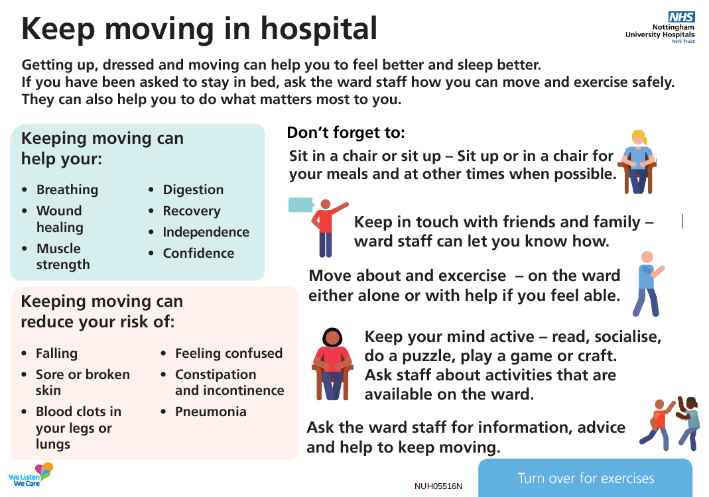

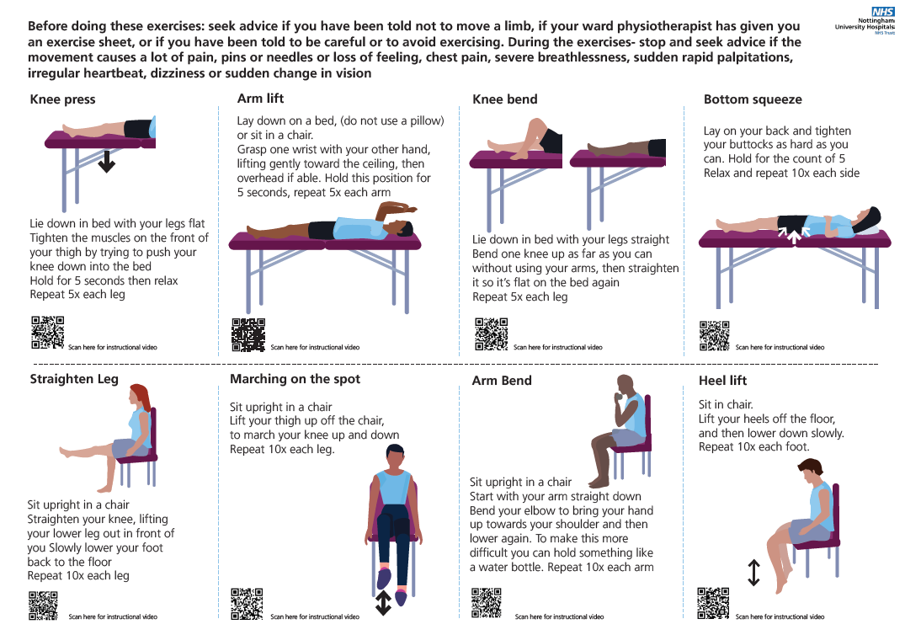

**Implementing the “Keep Moving” sheet with patients.**

**Ward Staff**

The sheet has been developed to be used by ward staff, volunteers and patients. By supporting patients with the bed and chair exercises, ward staff can help to minimise the risks of our patients deconditioning. All staff should complete the training linked here [active hospitals](http://nuhnet/diagnostics_clinical_support/Pages/active-hospitals.aspx) before using the sheet with patients, and view the exercises described on the sheet via the QR codes beneath each description. Contraindications to the exercises are listed in the training above. If you are unsure about your patients’ safety in relation to the exercises, consult a Therapist, and or member of the medical team.

**Volunteers**

Volunteers are being identified by the Voluntary Team, the project team, and in some cases recruited from Sports and Exercise medicine and Physiotherapy courses. All volunteers will have received online and face to face training from the project team on how to safely use the “Keep Moving” sheet before they come to the ward.

To support them to safely do so, it is important to:

* Welcome volunteers when they arrive on the ward.
* Identify patients who have been deemed as safe to complete the “Keep Moving” sheet, with regard to the contraindications noted in the training above.
* Consider adding this decision to staff handovers to cover volunteers coming at different times of the day.
* Ensure that identified patients are medically stable at the point of volunteer contact.
* Advise volunteers who they can safely see.
* Ensure that volunteers are monitored by ward staff while they are engaged in exercises with patients.
* Get feedback on the session from volunteers and patients. Copies of suitable feedback forms can be obtained from [jo.mcaulay@nuh.nhs.uk](mailto:jo.mcaulay@nuh.nhs.uk)

**Measuring outcomes.**

Before you start, discuss how you will measure change with the QSIR team [QSIR@nuh.nhs.uk](mailto:QSIR@nuh.nhs.uk)

Consider relevant factors such as hospital acquired pressure sores, falls, green vs red days, length of stay.

Discuss other outcome measures with your therapy team e.g. grip strength measurement, timed up and go.

Request Nervecentre dashboards to measure number of physical activity conversations, advice, and signposting to ward opportunities to be active. Contact [jo.mcaulay@nuh.nhs.uk](mailto:jo.mcaulay@nuh.nhs.uk) for advice on creating a dashboard.

References- Further Information on Deconditioning

☹

☺

☹

☺

☹

☺

☹

☺

☺

☺

Amit Arora (2019) Rapid response to: “Prevalence, severity, and nature of preventable patient harm across medical care settings: systematic review and meta-analysis”*BMJ*  pp 366

Bate, A (2017) “Delayed transfers of care in the NHS” *BRIEFING PAPER* House of commons library

Bender D, Holyoke P. (2018) “Why some patients who do not need hospitalization cannot leave: a case study of reviews in 6 Canadian hospitals”. *Healthcare Management Forum* 31(4) pp 121–5

Brown CJ, Redden DT, Flood KL, Allman RM. (2009) “The underrecognized epidemic of low mobility during hospitalization of older adults”. *Journal of American Geriatric Society.* Sep;57(9)

Clark D, Armstrong M, Allan A et al (2014) “Imminence of death among hospital patients: Prevalent cohort study”. *Palliative Medicine*, 28, 6, 474-479

Cortes, O.L., Delgado, S. Esparza, M. (2019) “Systematic review and meta analysis of experimental studies- In hospital mobilisation for patients admitted for medical treatment” *Journal of Advanced Nursing* 75 pp 1823-37

Crisafulli E, Barbeta E, Ielpo A, *et al.* (2018) ”Management of severe acute exacerbations of COPD: an updated narrative review”. *Multidisciplinary Respiratory Medicine* 2018;pp13-36.

De Morton NA, Keating JL, Jeffs K. (2007). Exercise for acutely hospitalised older medical patients. *Cochrane Database Systematic Review* Published Online First:

Di Girolamo, F. G., Fiotti N., Milanović Z., Situlin R., Mearelli F., Vinci P., Šimunič B., Pišot R., Narici M., Biolo G. (2021) “The Aging Muscle in Experimental Bed Rest: A Systematic Review and Meta-Analysis” *Frontiers in Nutrition* Volume 8

Department of Health and Social Care. (2019). *UK Chief Medical Officers’ Physical Activity Guidelines*. [www.gov.uk/government/publications/physical-activity-guidelines-uk-chief-medical-officers-report](http://www.gov.uk/government/publications/physical-activity-guidelines-uk-chief-medical-officers-report). Accessed 03/03/21.

Falvey JR, Mangione KK, Stevens-Lapsley JE. (2015) Rethinking Hospital-Associated Deconditioning: Proposed Paradigm Shift. *“Physical Therapy”* 95 (9) pp1307-15

Gillis A, MacDonald B. (2005) Deconditioning in the hospitalized elderly. *Canadian Nurse.*Jun;101(6) pp16-20.

Grant, P & Granat, Malcolm & Thow, Morag & Maclaren, William. (2010). Analyzing Free-Living Physical Activity of Older Adults in Different Environments Using Body-Worn Activity Monitors*. Journal of aging and physical activity*. 18. 171-84.

Guilcher, S.J.T., Everall, A.C., Cadel, L. *et al.* (2021). A qualitative study exploring the lived experiences of deconditioning in hospital in Ontario, Canada. *BMC Geriatric* 21

Haines, TP. (2007) Additional exercise for older subacute hospital inpatients to prevent falls: benefits and barriers to implementation and evaluation. *Clinical Rehabilitation* 21: 742–753

Hartley PJ, Keevil VL, Alushi L, Charles RL, Conroy EB, Costello PM, Dixon B, Dolinska-Grzybek AM, Vajda D, Romero-Ortuno R. (2019) “Earlier Physical Therapy Input Is Associated With a Reduced Length of Hospital Stay and Reduced Care Needs on Discharge in Frail Older Inpatients: An Observational Study”. *Journal of Geriatric Physical Therapy.* Apr/Jun;42(2)

Hoyer EH et al (2015) Barriers to early mobility of hospitalized general medicine patients: survey development and results. *American Journal of Physical Medicine and Rehabilitation*; 94: 4, pp 304-312

Kosse NM, Dutmer AL, Dasenbrock L, *et al.* (2013) Effectiveness and feasibility of early physical rehabilitation programs for geriatric hospitalized patients: A systematic review. *BMC Geriatrics* 2013;13.

Knight J et al (2019) Effects of bedrest 4: renal, reproductive and immune systems. *Nursing Times* [online]; 115: 3, pp 51-54 accessed 18/07/2022

Krumholz H.M. (2013) Post-hospital syndrome—an acquired, transient condition of generalized risk. *New England Journal of Medicine*

Martínez-Velilla N, Cadore EL, Casas-Herrero, *et al.* (2016) Physical activity and early rehabilitation in hospitalized elderly medical patients: Systematic review of randomized clinical trials. *J Nutr Heal Aging* 20 pp 738–51

LeBlanc AD, Schneider VS, Evans HJ, et al. (1992) Regional changes in muscle mass following 17 weeks of bed rest. *Journal of Applied Physiology.*

Moving Medicine [No evidence that it causes harm- (Hospital Associated Deconditioning Evidence) - Moving Medicine](https://movingmedicine.ac.uk/evidence/had-no-evidence-of-increased-adverse-events/) accessed 18/07/2022

Office for Health Improvement and Disparities. (2019). *Physical Activity: Applying All Our Health*. [www.gov.uk/government/organisations/office-for-health-improvement-and-disparities](http://www.gov.uk/government/organisations/office-for-health-improvement-and-disparities). Accessed 03/03/21.

Parry SM, Puthucheary ZA. (2015) The impact of extended bed rest on the musculoskeletal system in the critical care environment. *Extreme Physiolical Medicine*.

Public Health England. (2014). *Everybody Active, Every Day: An Evidence-Based Approach to Physical Activity*. [www.gov.uk/government/publications/everybody-active-every-day-a-framework-to-embed-physical-activity-into-daily-life. Accessed 03/03/21](http://www.gov.uk/government/publications/everybody-active-every-day-a-framework-to-embed-physical-activity-into-daily-life.%20Accessed%2003/03/21).

Pinkney, J., Rance, S., Benger, J., Brant, H., Joel-Edgar, S., Swancutt, D., Byng, R. (2016). How can frontline expertise and new models of care best contribute to safely reducing avoidable acute admissions? A mixed methods study of four acute hospitals. *Health Services and Delivery Research.* No. 4.3

Reid H., Ridout A.J., Tomaz S.A. on behalf of the Physical Activity Risk Consensus group*, et al* (2022) Benefits outweigh the risks: a consensus statement on the risks of physical activity for people living with long-term conditions *British Journal of Sports Medicine*56:427-438.

Sallis, R.E., Baggish, A.L, Franklin, B.A. & Whitehead, J.R. (2016). The call for a physical activity vital sign in clinical practice. *The American Journal of Medicine*, 129 (9), pp.903-905.

Social Care Institute of Excellence (2014) “NHS Benchmarking Network, National Audit of Intermediate Care 2014 summary report”. *Social Care Online* Accessed 18/07/2022

Spruit MA, Singh SJ, Rochester CL, *et al.* (2018) Pulmonary rehabilitation for patients with COPD during and after an exacerbation-related hospitalisation: back to the future? *European Respiratory Journal* 51

Stephenson J (2018) [Campaign to ‘end PJ paralysis’ saved 710,000 hospital days](https://www.nursingtimes.net/news/hospital/campaign-to-end-pj-paralysis-saved-710000-hospital-days-21-08-2018/). *nursingtimes. net*, Accessed 18/07/2022

Valenzuela PL, Morales JS, Castillo-García A, et al. (2020) Effects of exercise interventions on the functional status of acutely hospitalised older adults: A systematic review and meta-analysis. *Ageing Research Review* 61

Walker J et al (2018) Reducing the effects of immobility during hospital admissions. *Nursing Times* [online]; 114: 6, 18-20. Accessed 18/07/2022

Walthall, H. Dolan, B. Jackson, D. Trapped  in care:(2018)  Recognising and responding to frailty as a cause of delayed transfers of care *Journal of Clinical Nursing* 28(1-2) pp5-6

Williams JEA, Hussain SF, *et al.* (2014) An early rehabilitation intervention to enhance recovery during hospital admission for an exacerbation of chronic respiratory disease: Randomised controlled trial. *BMJ* 349 pp1–12.

World Health Organisation. (2020). *Physical Activity*. [www.who.int/news-room/fact-sheets/detail/physical-activity](http://www.who.int/news-room/fact-sheets/detail/physical-activity). Accessed 03/03/21.

World health Organisation (2022) “Global Status Report on Physical Activity” [Physical activity (who.int)](https://www.who.int/health-topics/physical-activity) Accessed 30/11/2022

Wen, P.C. & Wu, X. (2012). Stressing harms of physical inactivity to promote exercise. *The Lancet*, 380 (9838), pp.192-193.

Zhao, M., Veeranki, S.P., Li, S., Steffen, L.M. & Xi, B. (2019). Beneficial associations of low and large doses of leisure time physical activity with all-cause, cardiovascular disease and cancer mortality: A national cohort study of 88,140 US adults. *British Journal of Sports Medicine*, 53 (22), pp.1405-1411.

Zisberg, Shadmi, Efrat,Sinoff, et al. (2011). Low Mobility During Hospitalization and Functional Decline in Older Adults. *Journal of the American Geriatrics Society.* 59. 266-73.